

VIETNAM NATIONAL UNIVERSITY HCMC INTERNATIONAL UNIVERSITY

_____________________________________________

SCHOOL OF COMPUTER SCIENCE AND ENGINEERING

Academic Year: Second semester 2024 – 2025

**WEB APPLICATION DEVELOPMENT**

E-commerce website for automotive parts

**Member of group:**

|  |  |  |  |
| --- | --- | --- | --- |
| No. | Full name | Student ID | Email |
| 1 | Nguyễn Vũ Minh Thư | ITITWE21112 | ITITWE21112@student.hcmiu.edu.vn |
| 2 | Nguyễn Trung Tín | ITITDK21061 | ITITDK21061@student.hcmiu.edu.vn |
| 3 | Nguyễn Hải Quân | ITITWE21104 | ITITWE21104@student.hcmiu.edu.vn |

**Instructor:** Assoc. Prof. Nguyen Van Sinh

OUTLINES

I. INTRODUCTION 3

1. About Us 3

2. The Product’s Information 3

3. Development Environment 4

II. REQUIREMENT ANALYSIS AND DESIGN 5

1. REQUIREMENT ANALYSIS 5

Funtional Requirements 5

Non-Functional Requirements 10

2. DESIGN 12

ERD Diagram 12

Relational Schema Diagram 13

Class-Diagram 14

User Case Diagram 18

API 18

III. Frontend 18

1. Frontend Structure 18

2. Functionality 18

3. Frontend-Backend Integration 19

4. Frontend Implementation with Code Examples 19

4.1. Google Chart for admin 19

4.2 Google Column Chart in Statistical for admin 19

4.3 Customer Cart Page 20

1. Backend Structure 20

2. Database Design 20

3. System Architecture Overview 20

4. Backend Implementation with Code Examples 21

4.1. Database Connection Setup 21

4.2. Express Server Initialization 22

23

4.3. Admin Login Controller 23

4.4. User Management Controller 23

4.5. Statistical Report Controller 24

1. Users’ account 25

1.1 Account Management 25

1.2. Home 27

2. Admins’ Account 36

2.1 Login 36

2.2 Admins manager 37

VI. DISCUSSION AND CONCLUSION 44

VII. REFFERENCES 45

# INTRODUCTION

## About Us

In this section, we will introduce the nature of our project software development team, the "automotive parts selling project". We delve into the foundational aspects of our endeavor – an online platform for selling automotive parts – and highlight the challenges encountered throughout the project's development journey. We joined hands to realize a platform dedicated to trading automotive parts. Our collaboration harnesses our shared skills and vision, creating a user-centric digital space for buying and selling automotive parts.

## The Product’s Information

In today’s increasingly modern era, vehicles are everywhere, but the wide range of sources for automotive parts often leaves users overwhelmed. Consumers must carefully evaluate price and supplier reputation to avoid low-quality products or scams. The challenge lies in striking a balance between affordability and user-friendly features that appeal to a diverse global audience. The solution we propose is an automotive parts exchange website called “Auto parts Hub”, designed specifically to tackle these issues. By offering a streamlined and intuitive user experience combined with powerful functionality, Auto parts Hub aims to create a trustworthy marketplace that connects sellers and buyers efficiently. This initiative is fueled by our commitment to simplifying the process of finding the right part for every vehicle’s need and fostering a global community where users can quickly find exactly what they’re looking for—reliably and with confidence.

## Development Environment

* **Front-end**: Using NodeJS: Embedded JavaScript
* **Back-end**: Implementing NodeJS to handle server-side logic
* **Database**: Employing MySQL for data storage and management
* **Architecture**: Following the Model-View-Controller (MVC) for structuring code.
* **Version** **Control**: Managing code with GitHub to track changes and collaborate. Link GitHub: [E-commerce website for automotive parts](https://github.com/retawsolit/Project-SE)
* **Communication**: Using Discord for team meetings and discussions.
* **Task** **management**: Keeping track of work with Google sheet
* **Documentation**: Using JSON to store raw data

# REQUIREMENT ANALYSIS AND DESIGN

This section presents a customized requirements analysis and design framework for the development of the trading platform. It acts as a blueprint for the project implementation, specifying each feature along with the defined conditions, as well as the functional and non-functional requirements outlined by the client. During the development process, we will continuously update and improve future iterations, ensuring an accurate and comprehensive record of the project's progress.

## REQUIREMENT ANALYSIS

### **Funtional Requirements**

**Use case 1: Log in**

+ Product scope: Allows users to log into the system to perform their functions.

+ Main action:

|  |  |
| --- | --- |
| Actor: User | System |
| 1. Select the login function | 1.1 Display login screen |
| 2. Enter username and password | 2.1 Fail -> move to sub-action  2.2 Successful -> display screen |
| 3. End of use case |  |

+ Sub action

|  |  |
| --- | --- |
| Actor: User | System |
| 1. Password checking | 1.1 Noticed that there is wrong username or password  1.2 Pre-display login screen  1.3 Return to step 2 in main action |
| 2. Change password  2.1 Click “change password” in login screen  2.2 Enter old password and enter new password, replay new password  2.3 Enter new password | 2.1 Display screen to change password  2.2.1 Check old password  2.2.2 Check if the new password and re-entered new password are the same  2.3 Display successful notification screen |

+ Precondition: User must have an account on the system

+ Post-condition: User successfully logged in

**Use case 2: Manage accounts**

+ Product scope: Allows admin to manage customer accounts

+ Main action:

|  |  |
| --- | --- |
| User: Admin | System |
| 1. Click “manage account” to request | 1.1 Show form “manage account” |
| 2. Action (more details, lock, open account) | 2.1 Return the corresponding operation result |

+ Precondition: Already have an admin account

+ Post-condition: Manage all accounts

**Use case 3: Manage automotive parts**

+ Product scope: Allows admin to manage automotive parts in website

+ Main action:

|  |  |
| --- | --- |
| User: Admin | System |
| 1.1 Send a part management request  1.2 Select "Add Product"  1.3 Enter part details (e.g., name, category, compatibility, price, description)  1.4 Save the new part entry | 1.1 Show manage form  1.2 Show add product form  1.3 Send information of part and check information  1.4 Send notice back |
| 2.1 Send a part management request  2.2 Select "Update Product"  2.3 Modify the part details as needed  2.4 Save and update the product information | 2.1 Show manage form  2.2 Show update product form  2.3 Send information of part and check information  2.4 Send notice back |
| 3.1 Send a part management request  3.2 Select "Delete Product"  3.3 Confirm deletion and refresh the Manage Parts section | 3.1 Show manage form  3.2 Confirm delete and check validity  3.3 Send notice and result back |

+ Precondition: Already have an admin account

+ Post-condition: Manage all automotive parts

**Use case 4: Manage type of parts**

+ Product scope: Allows admin to manage types of all automotive parts

+ Main action:

|  |  |
| --- | --- |
| User: Admin | System |
| 1.1 Send a part type management request  1.2 Choose "Add Type of Product"  1.3 Enter new part type information  1.4 Save the new part type | 1.1 Display manage form  1.2 Show add type of product form 1.3 Submit part type information and validate the data 1.4 Send a success or error notice back to the user |
| 2.1 Send a part type management request  2.2 Choose "Update Type of Product"  2.3 Edit the existing part type information  2.4 Save and update the part type | 2.1 Display manage form  2.2 Show update type of product form 2.3 Submit updated part type information and validate 2.4 Send a success or error notice back to the user |
| 3.1 Send a part type management request  3.2 Choose "Delete Type of Product"  3.3 Update the Manage Part Types list | 3.1 Show manage form  3.2 Confirm delete and check validity  3.3 Send notice and result back |

+ Precondition: Already have an admin account

+ Post-condition: Manage all types of automotive parts

**Use case 5: Manage origin of products**

+ Product scope: Allows admin to manage origin of automotive parts.

+ Main action:

|  |  |
| --- | --- |
| User: Admin | System |
| 1.1 Send an origin management request  1.2 Choose “add origin”  1.3 Add information of origin  1.4 Save new type | 1.1 Show origin form  1.2 Show add origin form  1.3 Send information of origin and check validity  1.4 Send notice back |
| 2.1 Send an origin management request  2.2 Choose “Update origin”  2.3 Change information of origin  2.4 Update information of origin | 2.1 Show manage form  2.2 Show update origin form  2.3 Send information of origin and check information  2.4 Send notice back |
| 3.1 Send an origin management request  3.2 Choose “delete origin”  3.3 Update “manage origin” | 3.1 Show manage form  3.2 Confirm delete and check validity  3.3 Send notice and result back |

+ Precondition: Already have an admin account

+ Post-condition: Manage origin of automotive parts

**Use case 6: Manage bills**

+ Product scope: Allows admin to manage bills

+ Main action:

|  |  |
| --- | --- |
| User: Admin | System |
| 1.1 Send manage bill request  1.2 Choose to see more details  1.3 Choose back | 1.1 Show bill form  1.2.1 Check id of bill  1.2.2 Send back result  1.2.3 Send back notice  1.3 Return to home page |
| 2.1 Send manage bill request  2.2 Click received | 2.1 Show bill form  2.2 Update the bill |
| 3.1 Send manages bill request  3.2 Click cancelled | 3.1 Show bill form  3.2 Update the bill |

+ Precondition: Already have an admin account

+ Post-condition: Manage all bills

**Use case 7: Revenue statistics**

+ Product scope: Allows admin to compile revenue statistics

+ Main action:

|  |  |
| --- | --- |
| User: Admin | System |
| 1.1. Send a request for statistical management  1.2 Statistics of orders received  1.3 Choose time | 1.1 display statistics form  1.2 request time information  1.3.1 Check information  1.3.2 Send back result |
| 2.1. Send a request for statistical management  2.2 Statistics of cancelled orders  2.3 Choose time | 2.1 display statistics form  2.2 request time information  2.3.1 Check information  2.3.2 Send back result |
| 3.1. Send a request for statistical management  3.2 Statistics of best-selling orders  3.3 Choose time | 3.1 display statistics form  3.2 request time information  3.3.1 Check information  3.3.2 Send back result |

+ Precondition: Already have an admin account

+ Post-condition: Revenue Analysis

### **Non-Functional Requirements**

#### 1. Usability requirements:

* It is crucial to guarantee that all software components operate accurately and efficiently.
* The hosting environment must hold an active license to manage incoming requests effectively.
* A designated administrator should oversee regular software updates and actively monitor system errors.

#### 2. Usability Requirements:

* Structured and straightforward to understand.
* Clear and informative.
* User-friendly, enabling seamless learning and navigation.
* Allows users to accomplish tasks effortlessly and error-free.

#### 3. Humanity Requirements:

+ Detailed documentation is provided to ensure users can fully comprehend the system through thorough reading.

+ The graphical user interface (GUI) is designed intuitively to facilitate easy learning and quick user adaptation.

+ Responsive interfaces are a critical aspect, enhancing the overall user experience.

#### 4. Maintainability Requirements:

+ The system is built to support regular updates and modifications. Since users may have limited understanding of its internal processes, the development team must ensure the platform is user-friendly and straightforward for both users and maintenance staff.

+ The platform should offer intuitive features enabling users to easily update and manage information related to videos, channels, and viewer interactions.

+ The source code should be cleanly organized and thoroughly documented to improve readability and simplify future updates or debugging.

+ A well-defined and stable database architecture is essential to ensure a reliable foundation for maintenance and scalability.

## DESIGN

### **ERD Diagram**

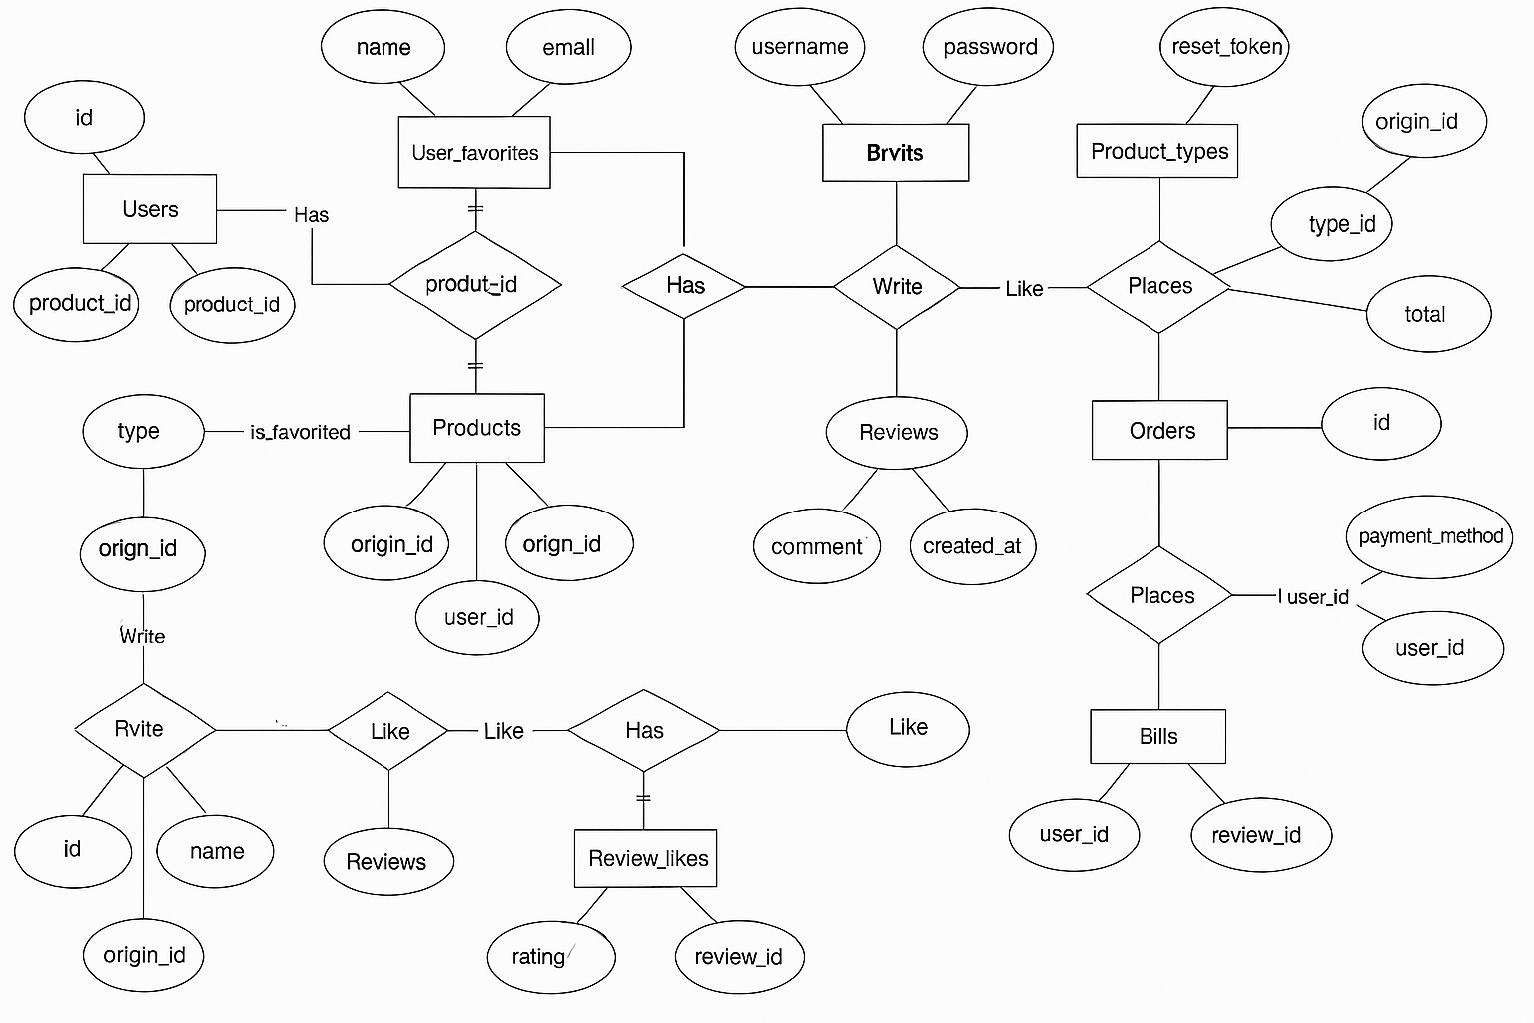

*This Entity-Relationship Diagram (ERD) illustrates the structure of the e-commerce platform's database. It includes all relevant entities such as Users, Admins, Products, Product Types, Origins, Orders, and Bills. Each entity is associated with its attributes and relationships, providing a comprehensive overview of how data is connected across the system.*

### **Relational Schema Diagram**

#### A diagram of a computer Description automatically generated with medium confidenceCustomer Back-end:

#### A diagram of a computer Description automatically generated with medium confidenceAdmin Back-end:

### **Class-Diagram**

#### A diagram of a computer Description automatically generatedFront-end

#### Back-end

#### LOGIC FLOW OF BACKEND API

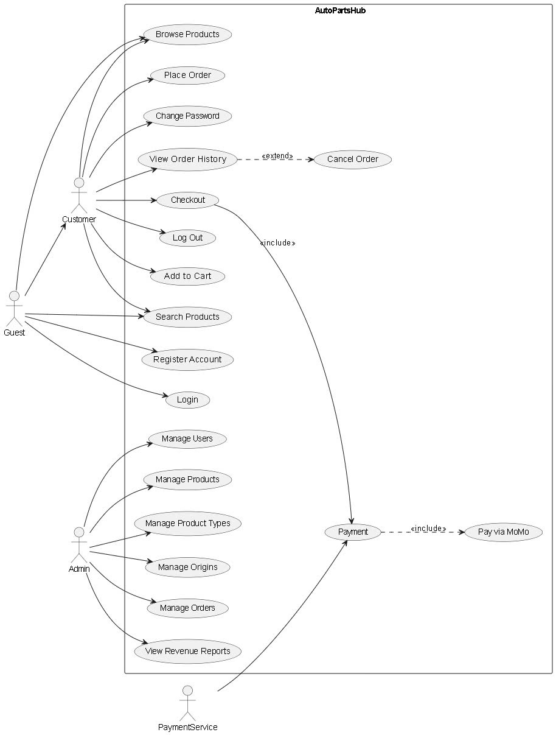

### **User Case Diagram**

### **API**

#### FRONT-END:

* + /login: Page for users to log in.
  + /home: Homepage displaying main content for users.
  + /header: Header section displayed on customer pages.
  + /sanpham: Page displaying products for customers.
  + /admin: Admin login page for administrative access.

#### BACK-END:

* + /api/admin/hd: Endpoint to manage admin header content.
  + /api/admin/home: Endpoint to manage admin home data.
  + /api/admin/login: Endpoint for admin login authentication.
  + /api/admin/statistical: Endpoint for retrieving statistical data.
  + /api/admin/user: Endpoint to manage user accounts.
  + /api/admin/sp: Endpoint for managing products.
  + /api/customer/header: Endpoint for retrieving customer page headers.
  + /api/customer/home: Endpoint for fetching customer home data.
  + /api/customer/login: Endpoint for customer login authentication.
  + /api/customer/sanpham: Endpoint for managing customer products.

# Frontend

## 1. Frontend Structure

The frontend of the project is responsible for rendering the user interface and handling user interactions. It ensures a responsive and intuitive experience, built using web technologies such as HTML, CSS, JavaScript, and a UI library is Ant Design.

- Static Files: Located in the public/ folder (e.g., CSS stylesheets, JavaScript files, images).

- Dynamic Templates: Found in the views/ folder, rendered by Express using res.render(). These are usually EJS (.ejs) or HTML files.

## 2. Functionality

* **Layout Rendering**: Pages such as home, login, vehicle listings, and product details are dynamically rendered based on user actions.
* **Styling**: Handled by custom CSS and/or external libraries to ensure consistent design and responsiveness across devices.
* **User Interaction**:
  + Forms for login/registration
  + Buttons and filters for vehicle/product searches
  + Dynamic elements that update without reloading the page
* **AJAX / Fetch API**: Frontend uses JavaScript (via fetch() or similar) to communicate with the backend in real-time. For example:
  + Fetching car data to populate listings
  + Submitting forms without page reload
  + Comparing multiple vehicles

3. Frontend-Backend Integration

- Backend APIs (possibly written in Java or Node.js) are called from the frontend to fetch or send data.

- JSON is commonly used for data exchange.

- Example flow: User selects a car → JavaScript sends request → Server responds with car info → Page updates dynamically.

# 4. Frontend Implementation with Code Examples

## 4.1. Google Chart for admin

- Loads the Google Charts library, enabling the visualization of data.

- Loads the corechart package and sets drawChart as the callback function once the chart library is ready.

## 4.2 Google Column Chart in Statistical for admin

- ColumnChart is used for clear comparison of product quantities.

* + Displays the selected date range dynamically using <%= dateStart %> and <%= dateEnd %>.

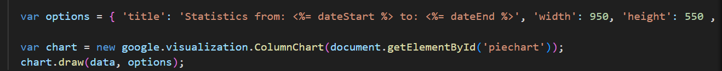

## 4.3 Customer Cart Page

- Solve and update data when customers have change

IV. Backend

# 1. Backend Structure

The backend is organized under the 'nodejs' directory. It includes the following main components:  
- connectDB.js: Establishes database connection  
- index.js: Main entry point of the server  
- controller/: Contains business logic split by user roles  
 - admin/: Admin-specific operations (user management, statistics, login, etc.)  
 - customer/: Customer-specific operations  
- package.json: Project dependencies

# 2. Database Design

The database schema is defined in the file 'data_create.sql'. It contains tables for managing users, products, orders, and related business entities. The design follows normalization principles for relational databases.

# 3. System Architecture Overview

The system architecture consists of three layers:  
1. Controller Layer: Handles HTTP requests and routes them to appropriate services.  
2. Service Layer (if applied): Encapsulates business logic (partially integrated into controllers).  
3. Data Access Layer: Interacts with MySQL database via SQL queries.  
  
Example flow:  
Client Request → Express Router → Controller → SQL Query → Database → Response

# 4. Backend Implementation with Code Examples

This section highlights key parts of the backend implementation with annotated code examples. Each snippet is essential to the operation and organization of the Node.js backend.

## 4.1. Database Connection Setup

**File:** nodejs/connectDB.js  
This file establishes a connection to the MySQL database using the 'mysql2' library.

## A screen shot of a computer program AI-generated content may be incorrect.4.2. Express Server Initialization

**File:** nodejs/index.js  
The entry point of the backend application, initializing Express and configuring middleware.

## A black background with colorful letters AI-generated content may be incorrect.4.3. Admin Login Controller

**File:** nodejs/controller/admin/loginController.js  
Handles the logic for admin login authentication.

## A screen shot of a computer program AI-generated content may be incorrect.4.4. User Management Controller

**File:** nodejs/controller/admin/userController.js  
Manages CRUD operations related to users.

## A screen shot of a computer program AI-generated content may be incorrect. 4.5. Statistical Report Controller

**File:** nodejs/controller/admin/statisticalController.js  
Retrieves and responds with summarized statistics from the database.

V. IMPLEMENTATION

## Users’ account

### 1.1 Account Management

#### 1.1.1 Login to application

**Step 1**: Click Account icon

**Step 2**: Enter the username and password of your account. Then click “**Login**”, the system will check if username and password is true it redirects to Home page. Otherwise, it will return the error message.

Error message will be appeared If the system recognizes that your account is incorrect or does not exist.

You will move to the homepage when login successful.

#### 1.1.2 Register

**Step 1**: If you don’t have any account, click “Sign up here”.

**Step 2**: Input username, password and re-password

Sign up page

### A screenshot of a computer AI-generated content may be incorrect.1.2. Home

Homepage

#### A screenshot of a phone AI-generated content may be incorrect.A screenshot of a phone AI-generated content may be incorrect.1.2.1 Products

When you click “Products”, the web will show all types of products, you click on the type you want, and the web will show the one you choose.

#### 1.2.2 Origin

When you click “Origin”, the web will show all origins of automotive parts, you click on the type you want, and the web will show the one you choose.

List of Products/Origin

#### 1.2.3 “Search” engine

You can search the car you want by type in “search” box

Searching **Loncin**

#### A screenshot of a computer AI-generated content may be incorrect.1.2.4 Account

Account drops down

#### 1.2.4.a Change password

**Step 1**: Click on “Change password” in account dropdown

**Step 2**: Input old password, new password and re-new password. After that, click “Change password”. If you don’t want to change your password, click “Back”

#### 1.2.4.b Cart

**Step 1**: Click to a product you want to buy, choose “Quantity to Buy” and click “Add to Cart”

**Step 2**: Fill in your personal information and click on “Continue shopping” if you want to add products or “Order” if you want to place an order

Cart Form

You can update the quantity of automotive parts or add automotive parts or delete automotive parts in cart.

**Step** 3: When done, the QR code will appear shortly and will be ready to receive your payment.



Or we can insert the Transaction code

After that, you click “I have completed the payment on the App” and there will be a confirmation message:

You can recognize the information by clicking the “order information”

When you click “Cancel Order”, the Order will be cancelled.

#### 1.2.4.c Existing orders

When you click “existing orders”, the web will show your all waiting order

#### 1.2.4.d Order history

When you click “Order history”, the web will show all your cancelled/completed order

## A login screen with blue and white text AI-generated content may be incorrect.Admins’ Account

### 2.1 Login

**Step 1**: Admin will have a private path to access, so customers will not be able to enter without knowing it.

**Step 2**: When you fill up the admin account, the web will show the manager screen

The main screen will show daily statistics

### A black text on a white background AI-generated content may be incorrect.2.2 Admins manager

Admin manages dropdown will be show when hover or click on it.

#### 2.2.1 Account

When you click “Account”, the web show lists of accounts.

List of users

You can find Account by search.

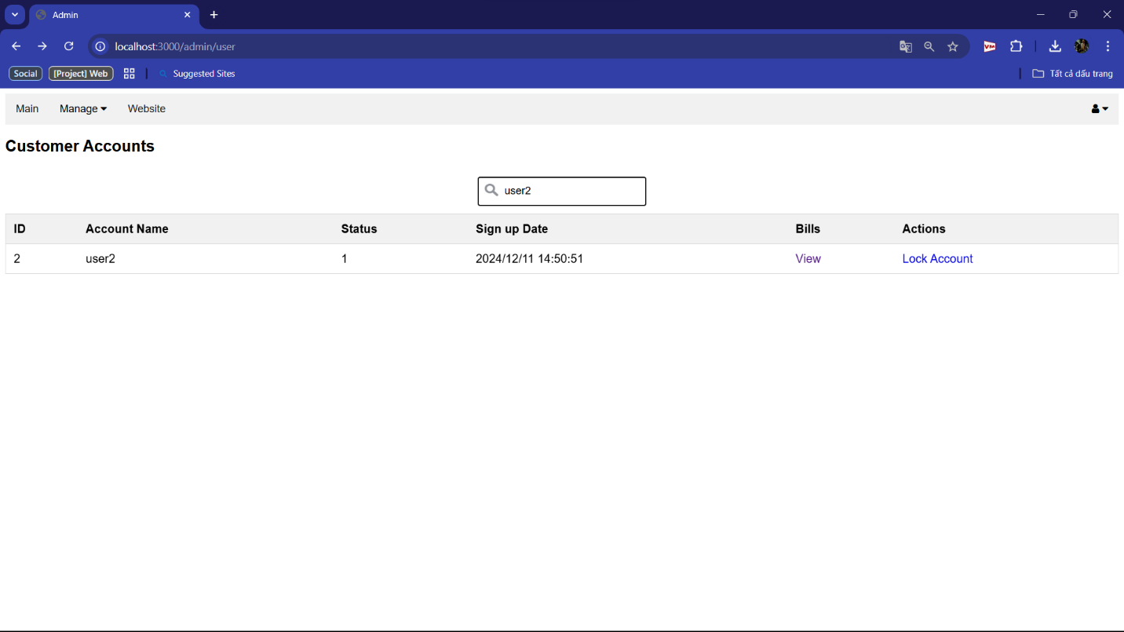Searching “user2”

When you click “Views”, it will show all details as pending/ cancelled/ completed order.

Click “view” to View more details in that bill.

You can unlock/lock account of customer.

#### 2.2.2 Manage type of products

When you click “Type of product”, it will show all types you have.

You can change the name of type of products when click “Change”

Then the name of products will be changed in the customer’s web

Hide/Show the type of products.

Then this type of product will be unavailable

#### 2.2.3 Manage origin of products

You can check the origin of car by click “Origin”, the action will the same as “ Type of Product”.

#### 2.2.4 Manage products

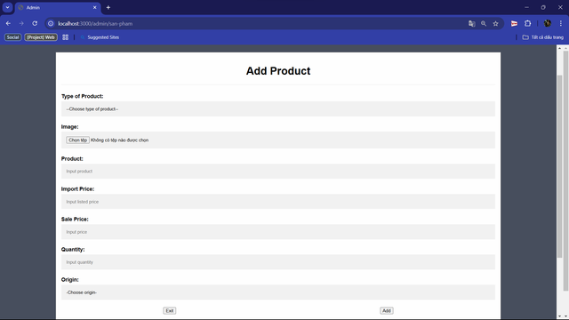

Add products

#### A screenshot of a computer AI-generated content may be incorrect.2.2.5 Bill management

More Information in Bill

#### 2.2.6 Statistical

# VI. DISCUSSION AND CONCLUSION

Developing an e-commerce platform tailored for automotive parts posed significant challenges, especially in managing an extensive inventory system and implementing a seamless parts comparison feature. One of the key hurdles involved efficiently storing and retrieving detailed vehicle data, encompassing images, specifications, and pricing information.

For the front-end, Node.js and the Ant Design (antd) library served as robust foundations, ensuring a modern, responsive, and intuitive interface. On the backend, built with Servlets, meticulous optimization was crucial to handle complex queries for filtering and sorting vehicle data. Docker containers were configured to enhance scalability, complemented by AWS services for secure image storage and rapid retrieval.

Implementing the vehicle comparison feature introduced another layer of complexity, necessitating precise synchronization between front-end and backend to ensure real-time updates to comparison lists, thereby enriching user experience.

This project provided an invaluable learning experience, offering insights into comprehensive web development and contemporary deployment techniques. Skills acquired included managing diverse data types, optimizing server performance, and enhancing user interaction. Utilizing these tools not only enhanced deployment proficiency but also underscored the importance of leveraging cloud services for scalable applications. Ultimately, this project fortified our technical expertise and prepared us for future advancements in web development and cloud computing.

# VII. REFFERENCES

1. Oracle, “Java EE 7 Tutorial: Servlets,” Oracle Documentation. [Online].
2. Vite. (n.d.). *Vite guide*.
3. MySQL Tutorial. (n.d.). *MySQL Tutorial*.
4. Java point. (n.d.). *Example to connect to the MySQL database*.
5. MySQL Documentation. (n.d.). *MySQL Documentation*.
6. W3Schools. (n.d.). *W3Schools Online Web Tutorials*
7. Baeldung. (2024, May 11). *Spring Boot Tutorial – Bootstrap a Simple Application*. Retrieved from Baeldung.
8. Rascia, T. (2017, December 07). *How to Connect to an API with JavaScript*. Retrieved from Tania Rascia Blog